

Insert the client logo here. If the logo is not applicable, remove this placeholder.

MOTOR HULL & MTPL
(Master Policy)

BUSINESS SOLUTION DOCUMENT
DD MMM YYYY
www.peak3.com
PRIVATE & CONFIDENTIAL
INCOME RFI
Table of Content
Document History 3
1 Introduction 4
1.1 Overview 4
1.2 Assumptions 4
1.3 End Users 4
1.4 Glossary 4
2 Requirement(s) 5
3 Business Solutions 5
3.1 Business Solution Overview/Summary 5
3.2 Function 1 5
3.2.1 Process Flow 6
3.2.2 Function Description 6
3.2.3 Business Rules 7
3.2.4 User Experience 8
3.2.4.1 UI_PRD_PRD_BasicInfo 8
4 Non-functional Requirement 9
5 Reference 9
Disclaimer 9

Document History

Date | Author | Version | Note | Reviewer
2024/11/27 | Ningyi | 1.0 | Updated descriptions based on internal discussion and BSD review | XXXX
2024/ 08/ 01 | Sean Cao | 0.2 | Added more details in the rule description | -
2023/ 09/ 04 | Sean Cao | 0.1 | Initial Draft | -

Introduction

Overview
Purpose of this document is to define product & pricing details, including policy issuance process for ABC client. XYZ product will be implemented in France, Spain, Italy and Germany. BSD will cover Liability, Coverage, Product and Plan definition….

Assumptions
API specifications will be covered in another document: link
Medical questionnaire will be defined in the Day 2 phase.

End Users
Call Center Agent, Agent, Policy Administrator, Claim Handler..

Glossary

Acronyms | Description
B2C | Business-to-Consumer – Refers to the direct sales journey for XYZ product
API | Application Programming Interface – Enables communication between systems for data exchange
Client | Refers to the insurance provider offering insurance products in France, Spain, Italy and Germany
Graphene | Central system managing workflow, product configuration, quotations, premium calculations, and integrations
Integration AAA | External system used to retrieve insurance benefits provided by credit cards
Integration BBB | External system that processes medical questionnaire responses to assess risk (France only)
Integration CCC | External system that processes medical questionnaire responses to assess risk (Italy only)

Requirement(s)
Jira Key | Version | Requirment
GIS-111251 [Product & Marketing] Weaken Coverage Period Type and Move Policy Type from Product to Package Level Closed | V2.82 | 3.1 Product Basic Information
GIS-109427 [Product & Marketing] update webpage style of Product & Marketing Center - sprint104 Closed | V2.81 | 3.2 Product Liability
- | - | -

Business Solutions

Business Solution Overview/Summary
This chapter outlines the travel insurance workflows (Regular and with credit card comparator), detailing its functionality, step-by-step process, data handling, field definitions, and specific business rules. It provides clarity on how customers interact with the system, the integrations involved, and the differences across regions.

Function 1
Description

Process Flow
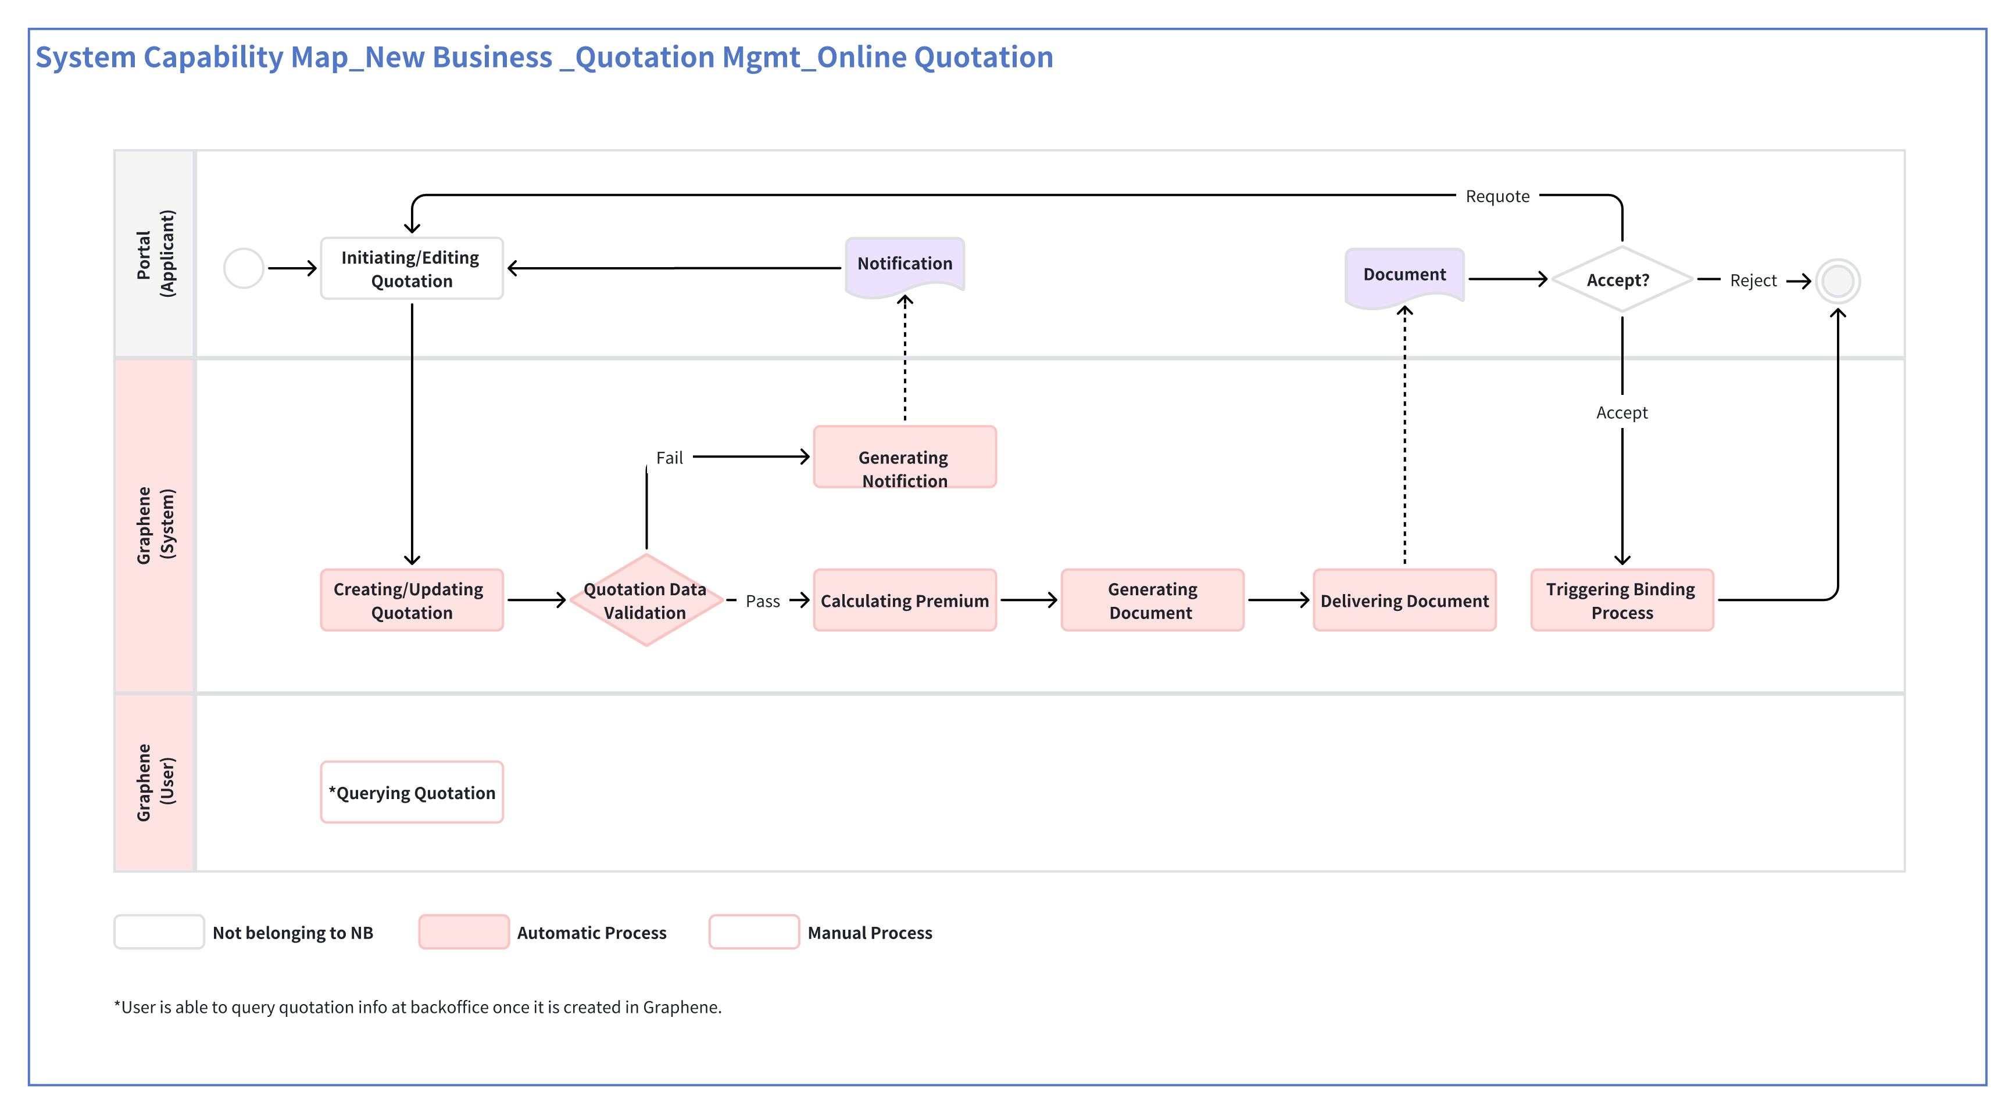

Function Description
- The user enters Product Management - Product Agreement page - Product Basic Info
Liability.
Please refer to UI_PRD_PRD_BasicInfo_ProductLiability
- If "Using Upgrade P&C Structure" is "Yes". Please refer to PRD_Interest_(Demo Only)_TBC.
End.
- If "Using Upgrade P&C Structure" is "No" or empty.
- The user adds, edits or deletes Liability.
For "Add":
- The user clicks the "Add New" button.
- The system shows the "Add New" drawer.
- Please refer to UI_PRD_PRD_BasicInfo_AddProductLiability
- The user selects a liability, and fills in required information.
- Please refer to BR_PRD_PRD_BasicInfo_AddProductLiability
- The user can click the "Add" button in the liability name dropdown to create a new liability.
Please refer to PRD_Liability Management_v2.80 (3.2 Add a new Liability)
For "Edit":
- The user clicks the "Edit" button.
- The system shows the "Edit" drawer.
- The user edits the product liability information.
- Please refer to BR_PRD_PRD_BasicInfo_EditProductLiability
- The system saves changes.
- End.

Business Rules
Rule Number &  Rule Name | Description
BR_PRD_PRD_BasicInfo_AddProductLiability | - Liability Category: The range of liability categories available for selection depends on the product template. Please refer to Annex: Product Template Details  - Liability Name:  - If a category is not selected and a liability is chosen directly, the corresponding category for that liability will be automatically filled in.  - At the bottom of the Liability Name dropdown, there is an "Add" button. If clicked, the system will show the "Add New Liability" drawer. Please refer to PRD_Liability Management_v2.80 (3.2 Add a new Liability)  - Optional / Required:  - Optional: When purchasing an insurance product, this liability is optional. When packaging a product into a package, this attribute can be redefined.  - Required: When purchasing an insurance product, this liability is mandatory.  - Incident Reason: The enumerations are defined in CFG Center - Tenant Data Configuration - Claim Enumerated Values - Incident Reason.  - Have SA:  - Yes: If SA is empty, the SA amount would be 0.  - No: No SA amount, the SA amount is null.  Liability Remark
BR_PRD_PRD_BasicInfo_EditProductLiability | The following attributes are editable:  - Optional / Required  - Incident Reason  - Have SA  Liability Remark

User Experience
First Level Menu | Second Level Menu | Third Level Menu | Page Name
Product Center | Product Management |  | UI_PRD_PRD_BasicInfo
Product Center | Product Management | Product Basic Info | UI_PRD_PRD_BasicInfo_Multi-LanguageOfProductName
Product Center | Product Management | Product Basic Info | UI_PRD_PRD_BasicInfo_ProductLabel  UI_PRD_PRD_BasicInfo_EditProductLabel

UI_PRD_Module_BasicInfo
<Screenshot or Figma UI>

Field Description
Lorem ipsum dolor sit amet, consectetuer adipiscing elit, sed diam nonummy nibh euismod tincidunt ut laoreet dolore magna aliquam erat volutpat. Ut wisi enim ad minim veniam, quis.

Information | Is this mandatory?  (Y/N) | Can it override an individual policy? (Y/N) | Rules
Master Policy Number | Y | N | Manually input by the underwriter, no special rule on the format.
Master Policy Effective Date | Y | Y | No special rule for master policy, individual policy effective date should be within master policy period.
Master Policy Expiry Date | Y | Y | No special rule for master policy, individual policy expiry date does not need to be within master policy period.
- | - | - | -
- | - | - | -

Non-functional Requirement(s)
< Event Tracking, Performance, Security, Compatibility, Legal Compliance, etc.>

Reference

NA

Disclaimer

The materials contained in this document are designed for the sole use by the designated recipient (“Recipient”) and solely for the limited purposes described in the document. The materials shall not be copied or given to any person or entity other than the Recipient (“Third Party”) without the prior written consent of Peak3.

Peak3 has made no undertaking to update these materials after the date hereof, notwithstanding that such information may become outdated or inaccurate. Further, Third Parties may not, and it is unreasonable for any Third Party to, rely on these materials for any purpose whatsoever. Peak3 shall have no liability whatsoever to any Third Party, and any Third Party hereby waives any rights and claims it may have at any time against Peak3 with regard to the services, this presentation, or other materials, including the accuracy or completeness thereof.

Receipt and review of this document shall be deemed agreement with and consideration for the foregoing.

